 | De La Salle University  College of Computer Studies  Computer Technology Department  Ethical Hacking
Module No. 1.0 – Kali Linux Familiarization

Name | : | Daniel Gavrie Y. Clemente

Objective
- To familiarize students with using the command line in Kali Linux
- To familiarize students with changing network configurations in Kali Linux
- To familiarize students with using simple applications in Kali Linux

Procedure

Starting up the Virtual Machine and logging-on to Kali Linux

- Boot up the virtual machine using VMware. If Kali Linux is not among the listed options, select “Open a Virtual Machine”; navigate to the folder of Kali Linux and select the virtual machine file.
- Click the snapshot button on the VMWare Toolbar 
- Name the snapshot Initial State. With this, you can restore the Kali to its initial state after doing some changes in the configuration.
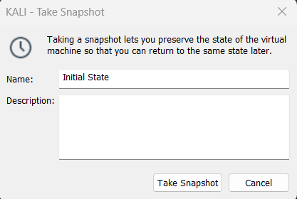
- When prompted for a login, type in the username “kali”, password is “kali”.

Commands in Kali
- You can click “Applications” and then “Kali Linux” to see the type of applications Kali Linux has.
- To open the command line interface, click on the “Terminal” icon at the top menu bar. It should open a Terminal application. You can open several Terminal applications at the same time.

Kali Linux file basic commands
- The pwd command is used to show the current directory. Enter this command in the Terminal. What is your current directory?
/home/kali

- The echo command. Type in the command below and observe the results.
echo My name is Alice
What does the echo command do?
It prints out whatever string you are trying to print out on the following line.

- The echo command is more useful when used together with the output redirection characters. The ‘>’ character is used to redirect any screen output to a file instead.
We will be creating a configuration file to allow the Kali Linux to use the DLSU proxy. Enter the command below in order to redirect the terminal output to a file named ‘proxy’
echo Acquire::http::proxy \”http://proxy.dlsu.edu.ph:80\”\; > proxy
- Verify that the file was created. Enter the command
ls –l
to list the contents of the root user home directory. Verify that the file named ‘proxy’ that you created is listed among the directory contents.
- Verify that the file contains the correct string. Enter the command below and observe the output
cat proxy
What does the cat command do?
The cat command shows Acquire::http::proxy ”http://proxy.dlsu.edu.ph:80”;

Verify that the proxy configuration string is output to the Terminal
- For the machine to use this configuration, the file must be copied to the /etc/apt/apt.conf.d system folder. To do so, enter the command:
cp proxy /etc/apt/apt.conf.d/proxy

Installing applications or services in Kali Linux – Using the “apt-get” command

- The APT package manager can be used to search for and install more features into the system. We will be using this to install an SSH service on the machine so that we can connect to it remotely.
- At the command prompt, type in the command
apt-get install ssh
This command will install the Secure Shell service, or “ssh” on your Kali Linux system.
- The “ssh” service allows you to remotely connect to your Kali Linux system using a secure shell terminal.
  - Configuring IP address in Kali Linux – Manual
- Open a Terminal application. On the prompt, type the command “ifconfig” to display the IP address of the system. What is the IP address of the system?
192.168.89.129

- On the prompt, type in the command “route” to display the default gateway of the system. What is the default gateway setting of the system?
192.168.89.2

- On the prompt, type in the command “cat /etc/resolv.conf” to show the DNS server setting of the system. What is the DNS server setting of the system?
192.168.89.2

- At the command prompt, type in the command
ifconfig eth0 <IP Address> netmask <Subnet Mask>
Use 192.168.10.50 for IP Address and 255.255.255.0 for Subnet Mask
- At the command prompt, type in the command
route add default gw <Default Gateway>”
Use 192.168.10.1 for default gateway
- At the command prompt, type in the command
echo nameserver <DNS Server IP> > /etc/resolv.conf
Use 192.168.10.1 for DNS Server IP
- This technique will set up the IP address setting of your Kali Linux system temporarily.
- What are the IP settings of the machine? Is it the same with your settings? (IP address, gateway, and DNS server settings)
The current IP settings of the machine are (IP address: 192.168.10.50, Gateway: 192.168.10.1, DNS server: 192.168.10.1). No, they are not the same as my settings.

Configuring IP address in Kali Linux – Static Configuration

- Reboot the machine, login, and then open a Terminal Application.
- What are the network settings of the machine? (IP address, gateway, and DNS server settings)
The current network settings of the machine are (IP address: 192.168.89.129, Gateway: 192.168.89.2, DNS server: 192.168.89.2).

- Are these settings the same as what you configured earlier? Why or why not?
No, the current network settings are not the same as what I configured earlier because the machine reset caused the network settings to reset to the proper and default settings.

- The etc/network/interfaces file is an example of a system configuration file. In particular, this file specifies network interface configurations to be set upon system boot up. In order to change network interface configurations that will persist even when you reboot the system, this file must be edited.
At the command prompt, edit the “/etc/network/interfaces” file. Use the “nano” application to edit the file, or by typing “nano /etc/network/interfaces”. Look for the portion of the file that has the same section as below:

allow hotplug eth0
iface eth0 inet dhcp

Place a hash character followed by a space “# ” at the beginning of these 2 lines to comment out these configurations. Add the following lines below:
auto eth0
iface eth0 inet static
address ww.xx.yy.zz
netmask qq.rr.ss.tt
network mm.nn.oo.pp
broadcast ii.jj.kk.ll
gateway aa.bb.cc.dd
Where:
ww.xx.yy.zz – IP address of the system
qq.rr.ss.tt – Netmask of the system
mm.nn.oo.pp – Network address of the system
ii.jj.kk.ll – Broadcast address of the system
aa.bb.cc.dd – Default gateway of the network

Use the IP settings from the previous section for configuring the addresses statically.
Click on Ctrl-O to save and Enter to overwrite the existing file
Click on Ctrl-X to exit the nano editor

- At the command prompt, edit the “/etc/resolv.conf”. Use the “nano” application to edit the file, or by typing “nano /etc/resolv.conf”. Comment out any existing configurations, then add a line “nameserver ee.ff.gg.hh” where “ee.ff.gg.hh” is the DNS setting of the network.
- Save and exit from nano.
- The network interface should be restarted for the changes to take effect. To restart the network, type in the command below at the Terminal
/etc/init.d/networking restart
- Did the IP settings change? Why?
No, the IP settings did not change because the process failed.

- From the VMware menu, click on VM🡪Settings…🡪Network Adapter. Change the network connection type to “Host-only.” Reboot Kali Linux. Are the network settings the same as the configured static settings? Why?
No, the network settings will not be the same as the configured static settings.

- Click on the Snapshot Manager . Restore the VM to its Initial State.

Starting a service in Kali Linux
- Open a Terminal application.
- At the command prompt, type in the commands
sudo ssh-keygen–f /etc/ssh/ssh_host_rsa_key –t rsa

Overwrite the existing file, then press Enter for no passphrase.
This generates the encryption keys of the Kali Linux SSH service.
/etc/init.d/ssh start
This will start the “ssh” service on your Kali Linux system.
- Install Putty from this website. https://www.putty.org/. Using the IP on your Kali Linux, login as Kali using Putty. Then accept to add the key to Putty’s cache. Then login using Kali default credentials. Type ifconfig then add the screenshot on the text box below.
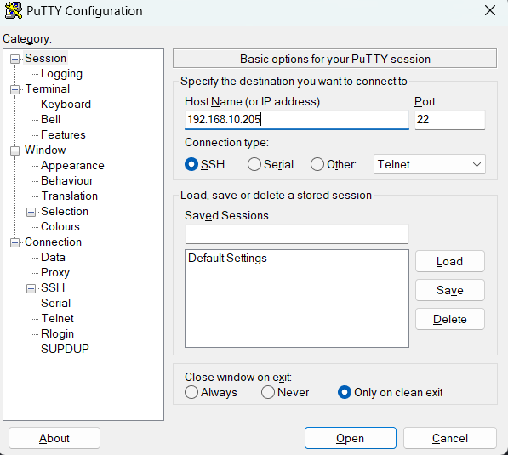
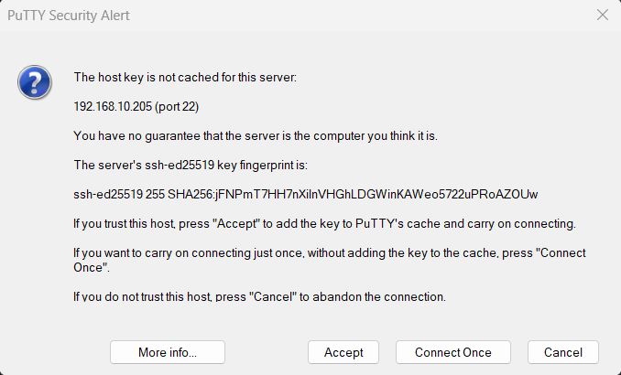.
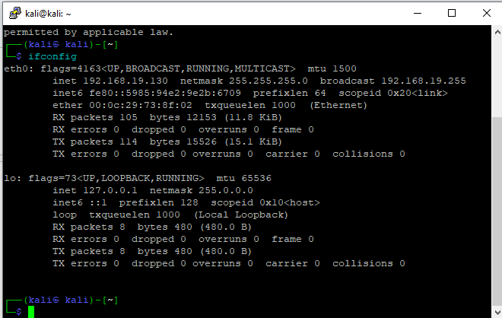

Guide Questions
- What is the Kali Linux distribution?
  - Kali Linux is a Debian-based Linux distribution designed for digital forensics, penetration testing, and cybersecurity tasks.
- What do the ifconfig and route commands do?
  - The ifconfig command is used to view and configure network interfaces, while the route command is used to display and manipulate the system's IP routing table.
- What are the important files to set the IP settings in Kali Linux?
  - Important files for setting IP configurations in Kali Linux include /etc/network/interfaces and /etc/resolv.conf for DNS settings.
- How do you reconfigure the settings back to DHCP after configuring the IP settings to static mode in Kali Linux?
  - To reconfigure settings back to DHCP in Kali Linux, you modify the network interface configuration (e.g., /etc/network/interfaces) to use iface eth0 inet dhcp and restart networking services.
- What is the apt-get command?
  - The apt-get command is a package management tool used to install, upgrade, or remove software packages in Debian-based systems like Kali Linux.

https://www.kali.org/get-kali/#kali-virtual-machines

